Creating a table named realestate and loading the given data

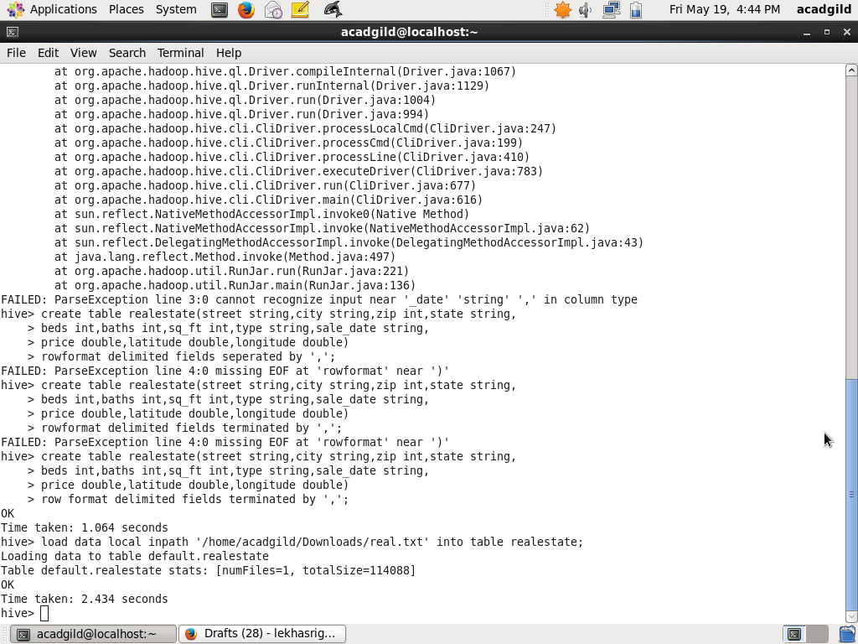

Creating a partition table realestate_part

create table realestate_part(city string,baths int,sq_feet int,price double)partitioned by(flat_type string,beds int);

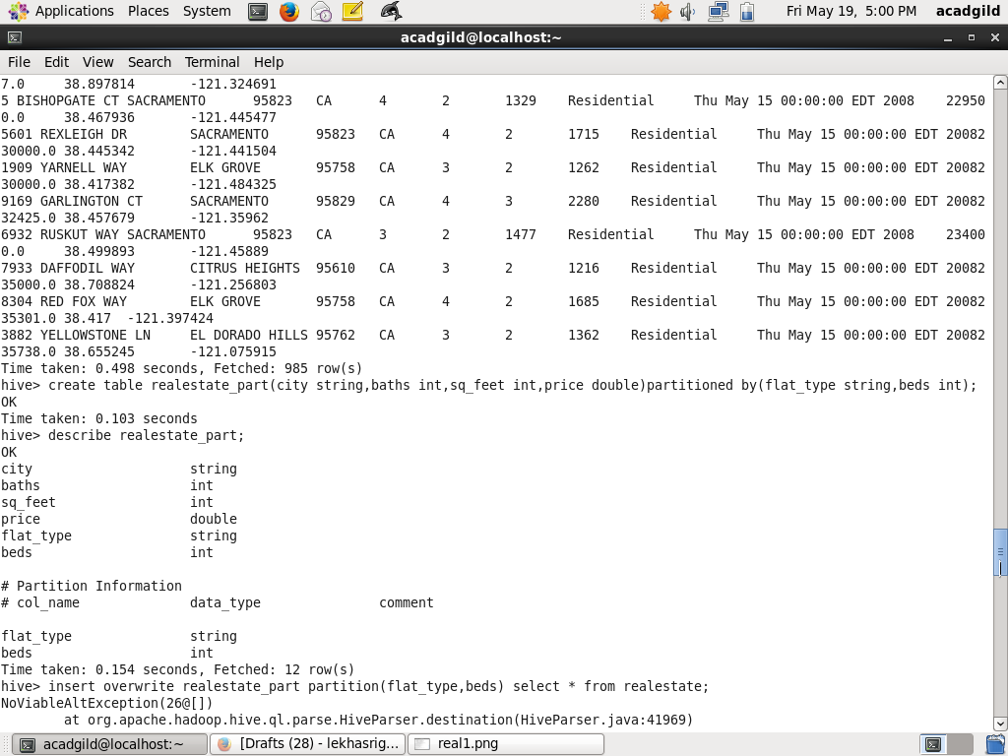

Inserting data inro partition table using dynamic partition mode

insert overwrite table realestate_part partition(flat_type,beds) select city,baths,sq_ft,price,type,beds  from realestate;

